Name : Aditi Paretkar

Roll no: 1911034

Batch : A3

Experiment 1 : code with output screenshots

Code:

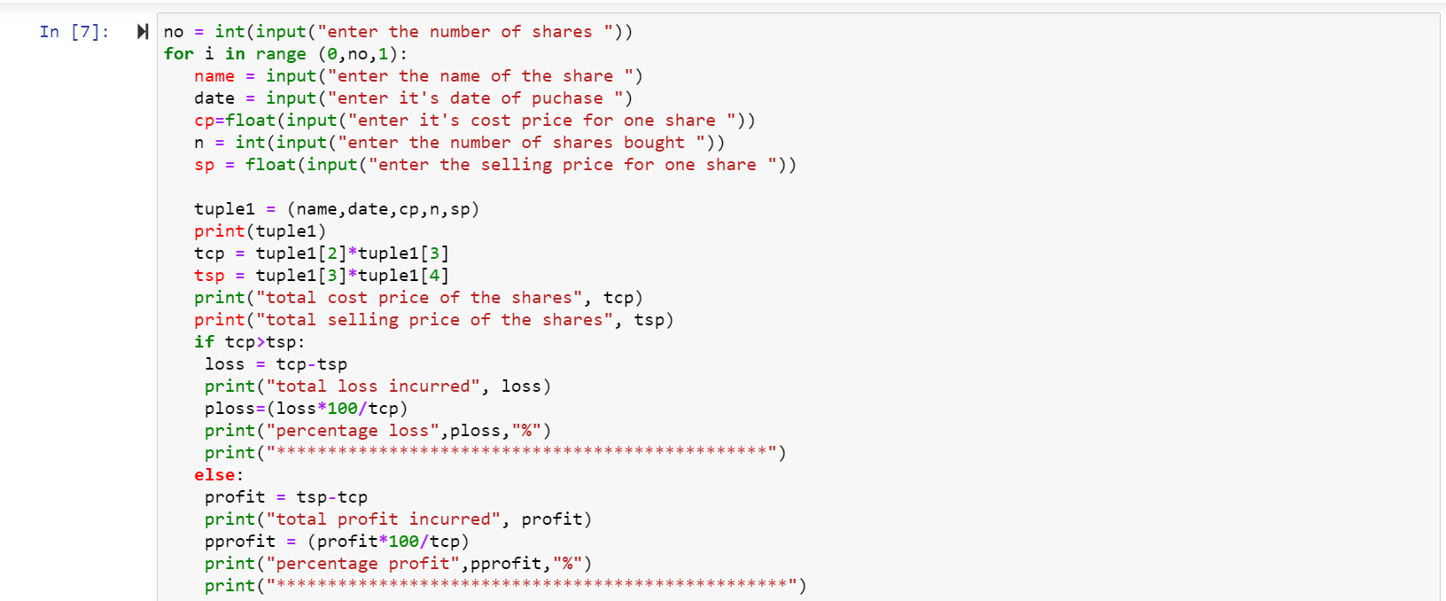

Output Screenshot:

